Project Planning Phase

**Project Planning Template (Product Backlog, Sprint Planning, Stories, Story points)**

|  |  |
| --- | --- |
| Date | 22 October 2022 |
| Team ID | PNT2022TMID52712 |
| Project Name | Project - Smart Lender - Applicant Credibility Prediction for Loan Approval |
| Maximum Marks | 8 Marks |

Product Backlog, Sprint Schedule, and Estimation (4 Marks)

|  |  |  |  |  |  |  |
| --- | --- | --- | --- | --- | --- | --- |
| **Release** | **Functional Requirement (Epic)** | **User Story Number** | **User Story / Task** | **Story Points** | **Priority** | **Team Members** |
| Sprint – 1 | **Forms** | USN – 1 | As a user, I can enter the data which I  have and also the data which the website asks to me | 6 | **Very High** | Hansika N,  PrateekshaPK,  Sarulathaa K  Bhuvanesh B |
| Sprint – 3 | **Prediction** | USN – 2 | As I have given the data into the webpage, now the data can be predicted for the loan avail | 4 | **Medium** | Hansika N,  PrateekshaPK,  Sarulathaa K  Bhuvanesh B |
| Sprint – 4 | **Deployment of the Webpage in Cloud** | USN – 3 | As a user, I require global access to the web page as a user | 3 | **Low** | Hansika N,  PrateekshaPK,  Sarulathaa K  Bhuvanesh B |
| Sprint – 4 | **Deployment of AI model in the cloud** | USN – 4 | Model would be running on the Cloud | 3 | **Low** | Hansika N,  PrateekshaPK,  Sarulathaa K  Bhuvanesh B |
| Sprint – 2 | **Model building** | USN – 5 | I require an ML model that can categorise  Credit defaulters | 5 | **High** | Hansika N,  PrateekshaPK,  Sarulathaa K  Bhuvanesh B |
| Sprint – 3 | **User Interface building** | USN – 6 | As a User, I need a medium to enter my data | 4 | **Medium** | Hansika N,  PrateekshaPK,  Sarulathaa K  Bhuvanesh B |

Project Tracker, Velocity & Burndown Chart: (4 Marks)

|  |  |  |  |  |  |  |
| --- | --- | --- | --- | --- | --- | --- |
| **Sprint** | **Total Story Points** | **Duration** | **Sprint Start Date** | **Sprint End Date (Planned)** | **Story Points Completed (as on**  **Planned End Date)** | **Sprint Release Date (Actual)** |
| Sprint-1 | 20 | 6 Days | 24 Oct 2022 | 29 Oct 2022 | 6 | 29 Oct 2022 |
| Sprint-2 | 20 | 6 Days | 31 Oct 2022 | 05 Nov 2022 | 6 | 6 Nov 2022 |
| Sprint-3 | 20 | 6 Days | 07 Nov 2022 | 12 Nov 2022 | 6 | 13 Nov 2022 |
| Sprint-4 | 20 | 6 Days | 14 Nov 2022 | 19 Nov 2022 | 6 | 19 Nov 2022 |

Velocity:

Imagine we have a 10-day sprint duration, and the velocity of the team is 20 (points per sprint). Let’s calculate the team’s average velocity (AV) per iteration unit (story points per day)

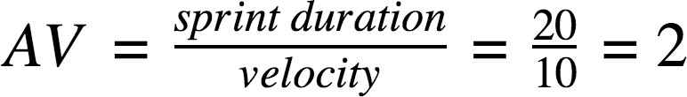

Burndown Chart:

A burn down chart is a graphical representation of work left to do versus time. It is often used in agile [software development](https://www.visual-paradigm.com/scrum/what-is-agile-software-development/) methodologies such as [Scrum](https://www.visual-paradigm.com/scrum/scrum-in-3-minutes/). However, burn down charts can be applied to any project containing measurable progress over time.

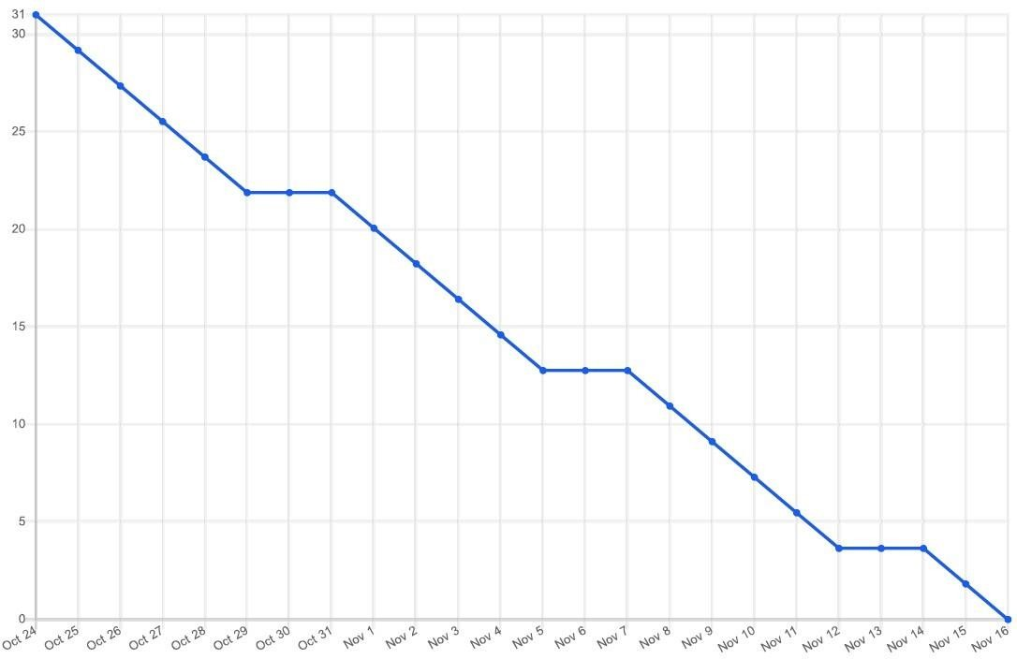

<https://www.visual-paradigm.com/scrum/scrum-burndown-chart/> <https://www.atlassian.com/agile/tutorials/burndown-charts>

Reference:

<https://www.atlassian.com/agile/project-management> <https://www.atlassian.com/agile/tutorials/how-to-do-scrum-with-jira-software> <https://www.atlassian.com/agile/tutorials/epics> <https://www.atlassian.com/agile/tutorials/sprints> <https://www.atlassian.com/agile/project-management/estimation> <https://www.atlassian.com/agile/tutorials/burndown-charts>